
Cognizant Technology Solutions India Private limited, Chennai
INTERNSHIP REPORT

TITLE: Programmer Analyst Trainee

DEPARTMENT OF ELECTRONICS AND COMMUNICATION ENGINEERING

NAME : Kajal B, Kaviya S
YEAR/SEM : IV / VII
PERIOD : 1.02.2021-28.7.2021
ROLE : INTERNS
DOMAIN : JAVA PROGRAM
LOCATION : Cognizant Technology Solutions India Private
Limited, Chennai

LEARNING JAVA PROGRAM
Abstract

Internet of Things (IoT) conceptualizes the idea of remotely connecting and monitoring real world objects (things) through the Internet [1]. When it comes to our house, this concept can be aptly incorporated to make it smarter, safer and automated. This IoT project focuses on building a “SMART HOME AUTOMATION SYSTEM” which is mainly concerned to design a system that allows users, upon authentication, to remotely control and monitor multiple home appliances using a cell-phone based interface. The leverage obtained by preferring this system over the similar kinds of existing systems is that the alerts and the status sent by the wifi connected microcontroller managed system can be received by the user on his phone from any distance irrespective of whether his mobile phone is connected to the internet. The microcontroller used in the current prototype is the TICC3200 Launchpad board which comes with an embedded micro-controller and an onboard Wi-Fi shield making use of which all the electrical appliances inside the home can be controlled and managed. Internet of things has been governing the electronics era with cloud services dominating the ever increasing electronics product segment. By using this we can switch on or off the lights or fans automatically when we are outside.
This proposes a smart home automation system based on Open source cloud server “things speak.com” and a low cost esp8266 Wi-Fi module. The System transmits an alert signal to the Open source cloud which provides a alert signal on the users mobile phone. The system employs a second esp8266 module which is programmed to act as a web server, which allows the user to activate or deactivate the security system by means of any device with internet. Smart connectivity with existing networks and context-aware computation using network resources is an indispensable part of IoT. With the growing presence of Wi-Fi and 4G-LTE wireless Internet access, the evolution towards ubiquitous information and communication networks is already evident.

INTRODUCTION
The IOIO-SHR is my first attempt in using Java to program a robot. Using a Sparkfun IOIO board to control the hardware and an Android phone as the robot brain. I must confess that I wasn't a friend of Java until yet, but the simple example programs for the IOIO board gave me a good starting point. IOIO board: The Sparkfun IOIO board is based on a PIC24F microcontroller. 48 IOs are available (digital I/O, analog In, special functions like I2C, SPI, PWM and UART).

LANGUAGE LEARNED
IOIO board:
The Sparkfun IOIO board is based on a PIC24F microcontroller. 48 IOs are available (digital I/O, analog In, special functions like I2C, SPI, PWM and UART). It has a USB host port to communicate with an Android phone via ADB interface (ADK is in an experimental state, Bluetooth can be done with an firmware upgrade). The best thing is, you don't need to program the IOIO board. It has a builtin firmware to talk to the Android phone. You only have to use the IOIO library in your Android Java program to get things done. The IOIO Library is very well designed and easy to use, similar to program an Arduino.
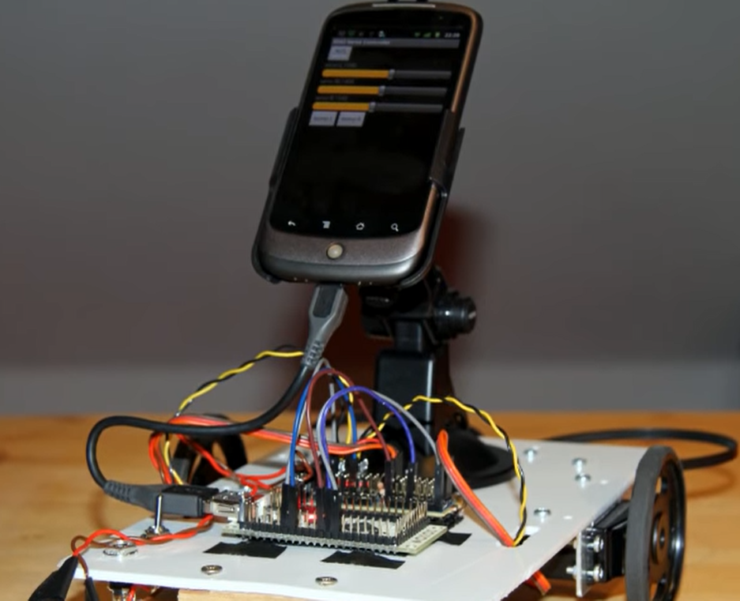
Introduction
However, for the Internet of Things vision to successfully emerge, the computing paradigm will need to go beyond traditional mobile computing scenarios that use smart phones and portables, and evolve into connecting everyday existing objects and embedding intelligence into our environment. For technology to disappear from the consciousness of the user, the Internet of Things demands: a shared understanding of the situation of its users and their appliances, software architectures and pervasive communication networks to process and convey the contextual information to where it is relevant, and the analytics tools in the Internet of Things that aim for autonomous and smart behavior. With these three fundamental grounds in place, smart connectivity and context-aware computation can be accomplished. A radical evolution of the current Internet into a Network of interconnected objects that not only harvests information from the environment (sensing) and interacts with the physical world (actuation/ command/control), but also uses existing Internet standards to provide services for information transfer, analytics, applications, and communications. Fueled by the prevalence of devices enabled by open wireless technology such as Bluetooth, radio frequency identification (RFID), Wi-Fi, and telephonic data services as well asembedded sensor and actuator nodes, IoT has stepped out of its infancyand is on the verge of transforming the current static Internet into a fully integrated Future Internet.

Methodology:
Our project aims to control or operate various equipment, machinery, industrial processes and other applications using various control systems with less or no human intervention. By using components of Power supply Board, Node MCU, 2 Channel Relay and alerting the user or the owner with a notification in the Blynk app so that the user can be able to operate if the lights or fans are left switched on.

Benefits to the company / institution through your report:
The Institute combines pioneering research with top class education. An innovative curriculum allows the student flexibility in selecting courses and projects. Students, even at the undergraduate level, get to participate in ongoing research and technology development - an opportunity unprecedented in India.

First tests:
For the first test of obstacle avoiding only 2 bumper sensors have been used. Not really elegant, but it is working. The bumper whiskers were made of cable ties applied to a snap-action switch. Unfortunately the whiskers fall apart very quickly. Need a better solution for this
.
Further tests:
- Improve obstacle avoiding with a distance sensor.

Todo List:
- add a distance sensor
- change servos against DC geared motors and motor controller
- improve battery runtime
- find out how to record videos work in background on Android
- Use the Android sensors (accelerometers, compass...)
- connect IOIO board and Android phone via Bluetooth

Results
The Android app has been extended to show the line sensor values in digital voltage values and an analog progress bar. It is nice feature to see the sensor values in real time on the phone screen.

Prepared by Verified by Approved by

